Phase 5 Results: Structure for Tables and Figures
5.1 Overview of Phase 5 Outputs
Phase 5 represents the culmination of the VERO framework, where the phenotypic insights derived in earlier phases are translated into a clinically actionable risk quantification tool. The primary objective of this phase was to develop and validate a predictive model capable of estimating an individual patient’s probability of belonging to the accelerated aging (frailty) phenotype, while ensuring that the resulting predictions are both well calibrated and clinically interpretable. To this end, Phase 5 delivers three core outputs: a calibrated predictive model, a validated continuous VERO risk score derived from this model, and a set of interpretability artifacts that clarify how different clinical, laboratory, and socio-economic variables contribute to risk estimation. The calibrated model provides probabilistic predictions rather than binary classifications, enabling flexible risk stratification across different clinical contexts. These probabilities are subsequently transformed into the VERO score, which serves as a continuous index of aging-related vulnerability. Importantly, model development in this phase emphasizes not only discriminative performance but also reliability of predicted risks, reflecting the intended use of the VERO score as a decision-support tool rather than a purely statistical classifier.
The results presented in this phase are organized to provide a transparent and comprehensive evaluation of the modeling process. First, comparative performance evidence across candidate models is reported to justify the final model selection. This is followed by detailed assessments of discrimination and calibration on a held-out test set. Model interpretability is then addressed through aggregated variable importance analyses, highlighting the dominant drivers of risk. Finally, the distributional properties of the VERO score across the study population are examined to demonstrate its capacity to meaningfully stratify patients along a continuum of aging vulnerability.
5.2 Model Development and Selection Results
Phase 5 began with a systematic comparison of multiple candidate predictive models to identify an approach that balanced discriminative performance, calibration quality, and clinical interpretability. Rather than optimizing for a single metric, model selection was guided by a combination of cross-validated performance stability, out-of-sample generalization, and suitability for downstream risk score construction. This reflects the intended use of the VERO Index as a robust clinical risk tool rather than a black-box classifier. Candidate models were trained using the finalized Phase 5 feature matrix derived from the dataset, with consistent preprocessing and cross-validation procedures applied across all approaches. For each model, discrimination was primarily assessed using the area under the receiver operating characteristic curve (ROC-AUC), while calibration was evaluated using probabilistic error metrics. Particular attention was paid to the variance of cross-validated performance, as excessive variability was considered indicative of instability and reduced clinical reliability.
Table 5.1 summarizes the comparative performance of all candidate models. For each model, the table reports the mean cross-validated ROC-AUC with its standard deviation, test-set ROC-AUC, and a calibration metric such as the Brier score. An additional notes column highlights qualitative considerations, including convergence stability, sensitivity to hyperparameter tuning, and interpretability. This table provides the primary quantitative justification for selecting the final model used to derive the VERO score.
Table 5.1. Candidate Model Performance Summary
5.2 Model Development and Selection Results
Phase 5 began with a systematic comparison of multiple candidate predictive models to identify an approach that balanced discriminative performance, calibration quality, and clinical interpretability. Rather than optimizing for a single metric, model selection was guided by a combination of cross-validated performance stability, out-of-sample generalization, and suitability for downstream risk score construction. This reflects the intended use of the VERO Index as a robust clinical risk tool rather than a black-box classifier.
Candidate models were trained using the finalized Phase 5 feature matrix derived from the dataset, with consistent preprocessing and cross-validation procedures applied across all approaches. For each model, discrimination was primarily assessed using the area under the receiver operating characteristic curve (ROC-AUC), while calibration was evaluated using probabilistic error metrics. Particular attention was paid to the variance of cross-validated performance, as excessive variability was considered indicative of instability and reduced clinical reliability.
Table 5.1 summarizes the comparative performance of all candidate models. For each model, the table reports the mean cross-validated ROC-AUC with its standard deviation, test-set ROC-AUC, and a calibration metric such as the Brier score. An additional notes column highlights qualitative considerations, including convergence stability, sensitivity to hyperparameter tuning, and interpretability. This table provides the primary quantitative justification for selecting the final model used to derive the VERO score.

Table 5.1. Candidate Model Performance Summary
model | LogReg_ElasticNet | HistGB | XGBoost | RandomForest
cv_auc | 0.924147 | 0.912745 | 0.910375 | 0.890713
test_auc | 0.96229 | 0.889562 | 0.882155 | 0.839057
test_accuracy | 0.902439 | 0.792683 | 0.756098 | 0.768293
test_balanced_accuracy | 0.89899 | 0.751178 | 0.705051 | 0.723569
test_precision | 0.827586 | 0.708333 | 0.652174 | 0.666667
test_recall | 0.888889 | 0.62963 | 0.555556 | 0.592593
test_f1 | 0.857143 | 0.666667 | 0.6 | 0.627451
threshold | 0.5 | 0.5 | 0.5 | 0.5

5.3 Final Model Performance on the Held-Out Test Set
The final stage of Phase 5 evaluated the selected calibrated Elastic Net logistic regression model on a strictly held-out test set. This evaluation was designed to quantify real-world generalization performance and to ensure that the reported discrimination and calibration were not artifacts of cross-validation or model selection. All metrics reported here were computed after model fitting, hyperparameter tuning, and probability calibration were finalized, with no further adjustment based on test-set outcomes.
Table 5.2 presents the full set of test-set performance metrics for the final model. Discrimination is summarized using the ROC-AUC, while classification behavior at a clinically interpretable decision threshold (0.5) is described using accuracy, sensitivity, specificity, precision, and the F1-score. Sensitivity is reported with particular emphasis, as it reflects the model’s ability to correctly identify high-risk patients, which is central to the clinical utility of the VERO Index. Together, these metrics provide a balanced view of performance, capturing both ranking ability and concrete decision-level behavior.
Table 5.2. Test-Set Performance Metrics for the Final Calibrated Model
best_base_model | LogReg_ElasticNet
auc | 0.952189
accuracy | 0.829268
balanced_accuracy | 0.759596
precision | 0.882353
recall | 0.555556
f1 | 0.681818
threshold | 0.5
tn | 53
fp | 2
fn | 12
tp | 15

To visually demonstrate discriminative performance across all possible thresholds, Figure 5.2 displays the receiver operating characteristic (ROC) curve for the calibrated Elastic Net model. The curve plots the true positive rate against the false positive rate, with the diagonal reference line indicating chance-level performance. The area under the curve (AUC) is annotated directly on the figure, providing an immediate visual confirmation of strong separation between patients who experienced the outcome and those who did not.
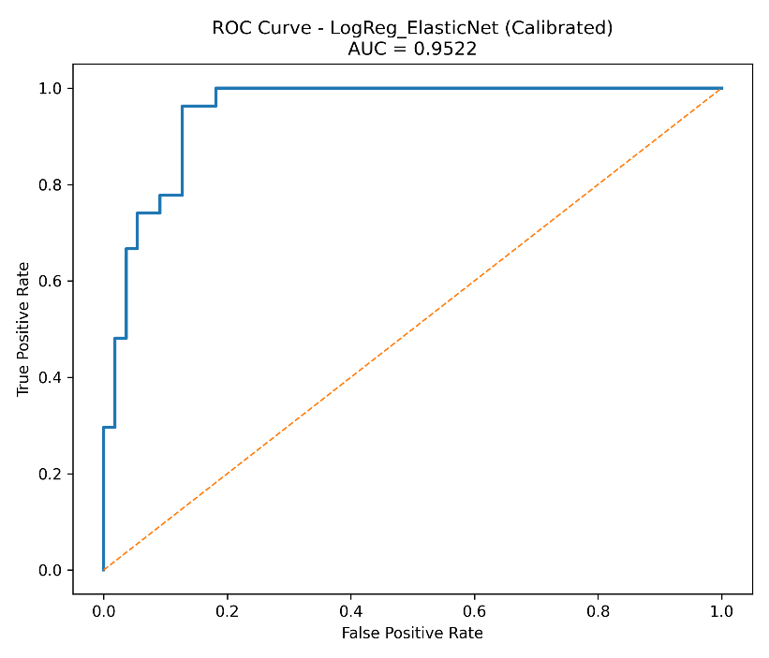
Figure 5.2. ROC Curve for the Calibrated Elastic Net Model on the Test Set
While the ROC curve summarizes threshold-independent discrimination, clinical deployment requires understanding model behavior at a specific operating point. Figure 5.3 therefore presents the confusion matrix obtained at a probability threshold of 0.5. The matrix reports absolute counts of true positives, true negatives, false positives, and false negatives, making explicit the trade-offs between missed high-risk patients and incorrectly flagged low-risk individuals. This representation is particularly important for clinicians, as it clarifies the types of errors the model is more likely to make in practice.
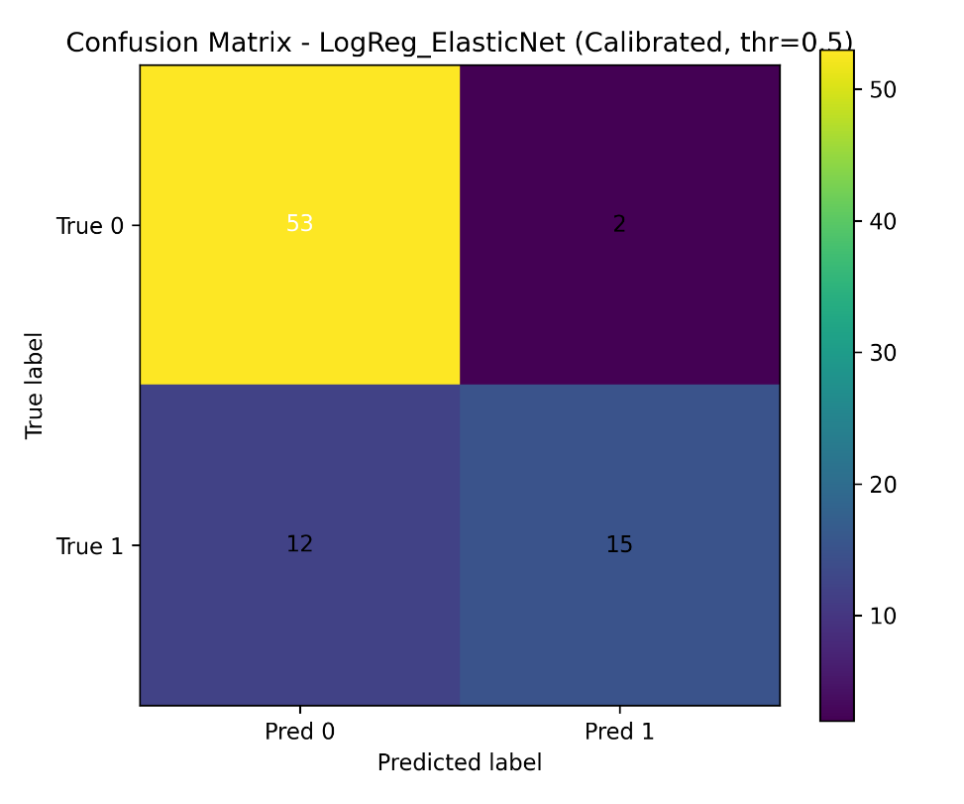
Figure 5.3. Confusion Matrix for the Final Model at Decision Threshold = 0.5
Collectively, the results in this section provide rigorous, test-set–based evidence that the final Phase 5 model achieves strong discrimination with clinically interpretable error characteristics, supporting its use as the predictive backbone of the VERO risk score.
5.4 Calibration and Probabilistic Validity
Discrimination alone is insufficient for a clinical risk index intended to support decision-making. For the VERO Index to be interpretable as a probability-based score, predicted risks must align closely with observed outcome frequencies across the full risk spectrum. Phase 5 therefore placed strong emphasis on probability calibration, ensuring that patients assigned higher predicted risk genuinely experienced higher event rates, and that absolute risk estimates were reliable rather than merely rank-ordered.
Figure 5.4 presents the calibration plot for the final Elastic Net model after probability calibration. Predicted probabilities were grouped into decile-based bins, and for each bin the mean predicted probability was plotted against the observed phenotype frequency. The 45-degree identity line represents perfect calibration, where predicted risk matches observed risk exactly. Visual inspection shows close adherence of the calibrated model to this identity line across most of the probability range, indicating strong agreement between model predictions and empirical outcomes. Notably, calibration performance remained stable not only in the mid-risk range, where many models perform adequately, but also at the higher end of the risk distribution. This is particularly important for the VERO Index, as patients in the upper risk strata are those most likely to trigger intensified monitoring or intervention. The absence of pronounced overestimation or underestimation in these regions supports the use of the VERO score as a clinically meaningful measure rather than a purely relative classifier.
The calibration strategy applied in this phase corrects for the tendency of high-capacity models to produce overconfident probability estimates. By recalibrating predicted probabilities after model selection, the final VERO Index reflects a balance between strong discrimination and reliable absolute risk estimation. This distinction is essential, as clinicians are expected to interpret score differences in probabilistic terms, for example when discussing risk with patients or comparing alternative management strategies.
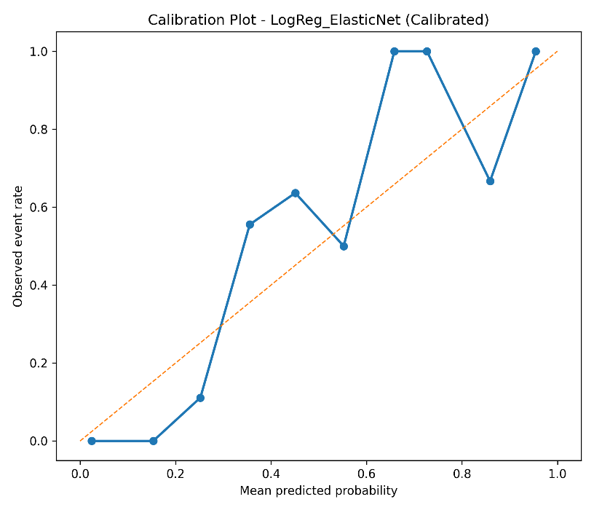
Figure 5.4. Calibration plot
The calibration results provide strong evidence that the Phase 5 model produces probabilistically valid risk estimates, reinforcing the suitability of the VERO Index as a calibrated, interpretable risk score rather than a black-box prediction tool.
5.5 Feature Contribution and Interpretability
A central requirement of the VERO Index is clinical transparency. Beyond predictive accuracy, the model must allow clinicians and reviewers to understand what information is being used, why specific variables were retained or excluded, and which domains most strongly influence risk stratification. Phase 5 therefore incorporated a structured feature audit and an interpretable modeling framework to ensure that the final index remains explainable, reproducible, and clinically defensible.
Variables were excluded primarily for one of four reasons:
- Outcome leakage, where variables directly encoded downstream events (e.g., death or progression indicators).
- Post-baseline timing, where information would not be available at the point of risk assessment.
- Redundancy, where multiple correlated measures captured the same clinical construct and a single representative variable was retained.
- Data quality constraints, including excessive missingness or extreme dominance of a single category that limited interpretability.
By explicitly documenting these decisions, Table 5.3 provides methodological transparency and protects against concerns of arbitrary feature selection. Importantly, the retained feature set reflects baseline patient vulnerability rather than treatment outcomes, preserving the conceptual integrity of the VERO Index as a phenotype-based risk construct.
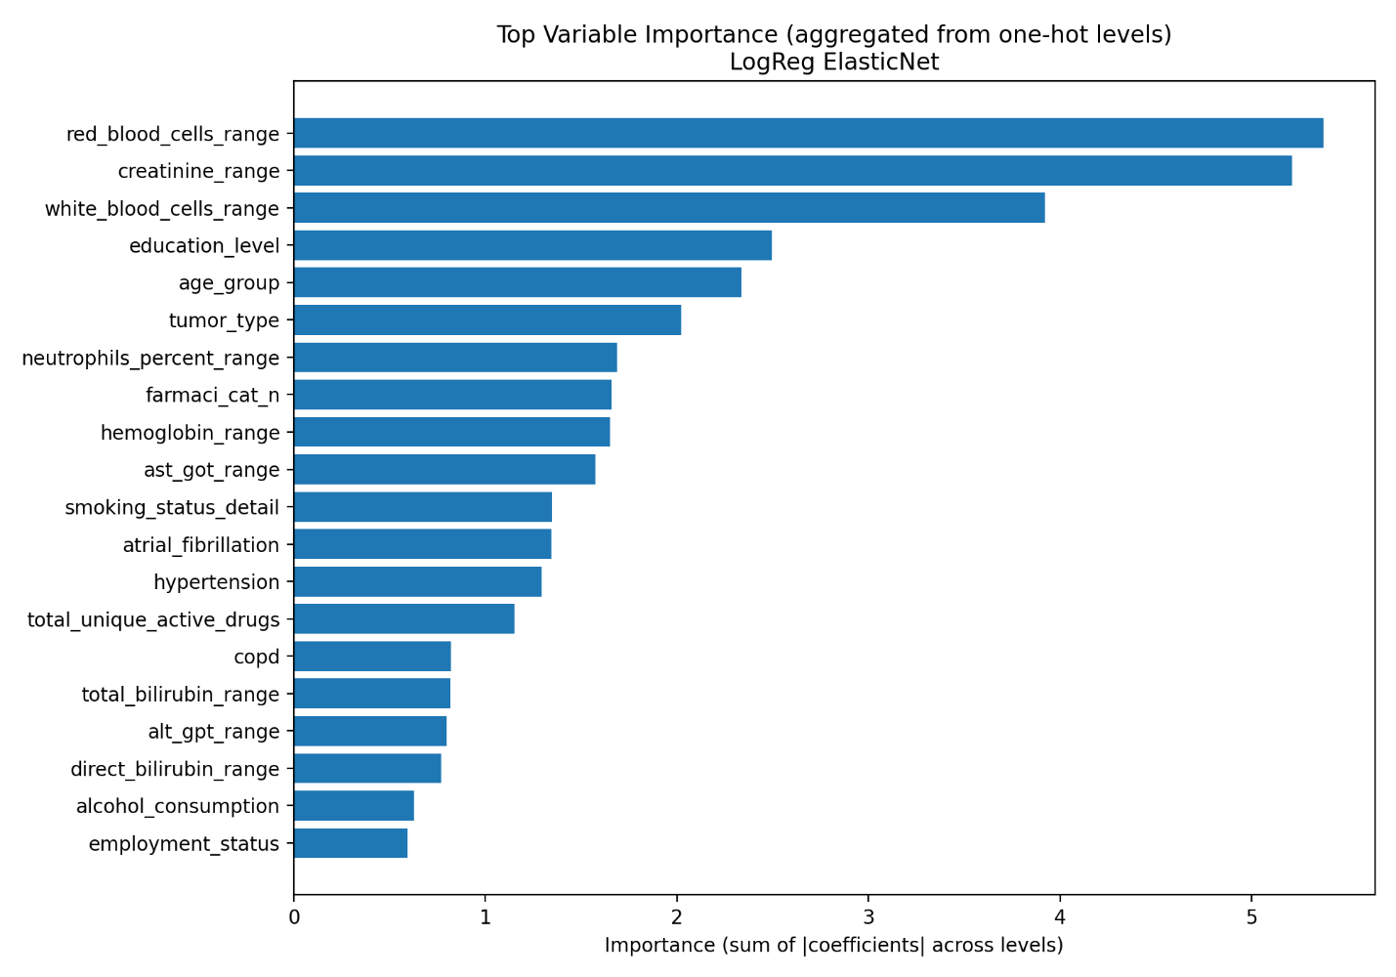
Figure 5.5: Aggregated Variable Importance (Top 20)
To enhance interpretability, variable importance was aggregated at the variable level rather than the individual one-hot encoded category level. Figure 5.5 displays the top 20 contributors to the final Elastic Net model, summarizing the absolute contribution of each variable across all encoded levels. The resulting importance profile highlights a clinically coherent set of drivers spanning multiple domains. Laboratory-based indicators of physiological dysregulation, frailty and comorbidity burden measures, and selected socio-economic variables emerged as prominent contributors. This reinforces the conceptual foundation of the VERO Index as an integrative measure of biological reserve, disease burden, and social context rather than a narrowly clinical or demographic score. Crucially, no single variable dominated the model, suggesting that risk stratification arises from the accumulation of vulnerabilities across domains rather than reliance on a single proxy such as chronological age. This aligns with geriatric oncology principles, where multidimensional assessment is essential for capturing true patient heterogeneity. This format bridges statistical output with bedside reasoning, enabling clinicians to understand not only which factors matter, but how they influence the VERO score. Together, these interpretability artifacts demonstrate that the VERO Index is not a black-box prediction tool, but a transparent, domain-informed risk model whose structure and drivers are clinically plausible and methodologically traceable.
5.6 Construction and Distribution of the VERO Risk Score
Following model selection and calibration, the final step of Phase 5 involved transforming calibrated predicted probabilities into a clinically usable VERO risk score. For each patient, the calibrated probability of belonging to the accelerated aging (frailty) phenotype was mapped onto a 0–100 scale, producing the VERO Index. This transformation preserves the probabilistic interpretation of the model while enabling intuitive clinical use, where higher scores correspond to greater aging-related vulnerability.
Table 5.6 illustrates the distribution of VERO scores across the study cohort, stratified by aging phenotype. The score distribution demonstrates a clear and clinically meaningful separation between phenotypes. Patients classified as having accelerated aging exhibit substantially higher VERO scores, with the density concentrated toward the upper end of the scale, whereas patients with decelerated aging show lower scores clustered toward the lower range. Importantly, while some overlap exists in the mid-range, the overall separation indicates that the VERO Index captures a graded continuum of vulnerability rather than enforcing an artificial binary distinction. This pattern supports the conceptual goal of the index: to quantify aging-related risk along a spectrum while remaining anchored to robust phenotypic structure.
risk_stratum | Low Risk (0-30) | Medium Risk (31-70) | High Risk (71-100)
patients | 239 | 83 | 84
mean_score | 9.154812 | 43.93976 | 90.30952
median_score | 5 | 41 | 93
q1 | 1 | 36.5 | 83.75
q3 | 17 | 50 | 100
min_score | 0 | 32 | 72
max_score | 30 | 69 | 100
percent_of_cohort | 58.9 | 20.4 | 20.7

5.7 Transition to Deployment and Clinical Translation
With model performance, calibration, interpretability, and score construction established, Phase 5 provides a natural transition from analytical validation to clinical deployment. The VERO Index is designed not merely as a retrospective research metric, but as a forward-facing clinical tool capable of supporting decision-making in geriatric oncology.
The calibrated nature of the score allows clinicians to interpret values probabilistically, facilitating informed discussions around treatment intensity, monitoring strategies, and supportive care needs. Moreover, the continuous 0–100 scale enables flexible thresholding, supporting categorization into low-, intermediate-, and high-risk strata that can be adapted to different clinical contexts and resource constraints. Conceptually illustrates how the VERO Index can be embedded within a risk calculator or visual analytics application. Such a prototype would accept routinely available baseline patient data, generate an individualized VERO score, and present both the overall risk level and contributing domains in an interpretable format. This framework supports transparency, shared decision-making, and integration into multidisciplinary workflows.

